DESIRE OF NATIONS REDEEMER SCHOOL

**ASSIGNMENT**

PRE- NURSERY

LETTERWORK

1. Sound and copy these letters;

a ------- ------- --------- -------- --------

a ------- -------- --------- -------- ---------

a -------- -------- --------- -------- ----------

b -------- -------- --------- ---------- ----------

b -------- -------- ---------- --------- ---------

b ------- -------- --------- ---------- ----------

c ------- ------- --------- ---------- -----------

c ------- --------- ---------- ---------- ----------

c ------- --------- --------- ---------- ----------

d ------- --------- --------- --------- ---------

d ------ -------- ---------- ---------- ----------

d ------- --------- ---------- ---------- ------------

e ------- --------- ----------- --------- -----------

e -------- --------- ---------- --------- -----------

e -------- ------- ------- --------- ---------

f -------- ------- -------- ---------- --------

f -------- --------- -------- --------- ---------

f ------- ---------- --------- ---------- ----------

g -------- --------- ---------- ---------- ----------

g --------- ---------- --------- ----------- ---------

g -------- --------- ---------- -------- --------

h --------- ---------- ---------- -------- --------

h -------- ---------- ---------- --------- --------

h -------- ---------- --------- -------- --------

i -------- --------- ---------- -------- --------

i -------- --------- --------- -------- ---------

i --------- ---------- --------- -------- ---------

j -------- ---------- --------- --------- ---------

j --------- ---------- --------- -------- ----------

j ---------- --------- ---------- -------- -----------

k --------- ---------- ---------- ---------- --------

k -------- ---------- --------- -------- --------

CIRCLE THE LETTERS THAT ARE THE SAME WITH THE ONE AT THE MARGIN

|  |  |  |  |  |  |  |  |  |  |
| --- | --- | --- | --- | --- | --- | --- | --- | --- | --- |
| **m** | t | m | o | a | m | y | m | b | l |
| **n** | h | d | n | k | f | n | p | n | J |
| **o** | g | o | v | o | x | z | o | c | o |
| **p** | m | v | p | n | p | r | w | p | c |
| **r** | t | r | h | u | r | j | o | r | f |
| **s** | s | c | a | s | x | s | z | s | o |
| **t** | v | t | b | t | g | t | w | t | t |
| **u** | u | q | L | u | j | u | t | d | u |

WRITE THE BEGINNING SOUND OF THESE OBJECTS

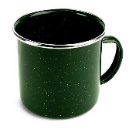 c

-------------

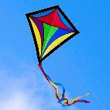

-----------

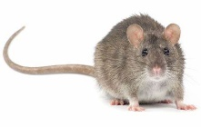

-----------

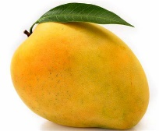

---------

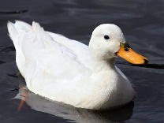

-----------



-------------

NUMBERWORK

Count and write numbers from 0 --- 25

|  |  |  |  |  |  |  |  |  |  |
| --- | --- | --- | --- | --- | --- | --- | --- | --- | --- |
|  |  |  |  |  |  |  |  |  |  |
|  |  |  |  |  |  |  |  |  |  |
|  |  |  |  |  |  |  |  |  |  |

Fill in the missing numbers

0 ------- 2 --------- 4 --------- 6 -------- 8 --------

10 --------- 12 ------- 14 -------- 16 ---------- 18

--------- 20 -------- 22 -------- 24 -------- 26

Match the similar numbers

19 18

18 17

17 16

16 20

20 19

Copy these numbers

10 ------- -------- -------- --------- -------

11 ------- -------- -------- -------- --------

12 ------- ------- --------- ------- ---------

13 ------- ------- ------- ------- ----------

14 -------- ------- ------- ------- ---------

15 ------- --------- --------- --------- ---------

16 --------- ---------- --------- ---------- ----------

17 --------- ---------- ----------- ----------- -----------

18 ---------- ---------- ----------- ----------- ------------

19 ----------- ----------- ---------- ------------ ------------

20 ----------- ------------ ---------- -------------- -------------

Count these objects and write the correct answer.

=

=

=

=

   =

=

=

Count these objects and match them to the correct answer

   12

  

     6

    

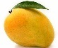 10



1

4

d

5

3